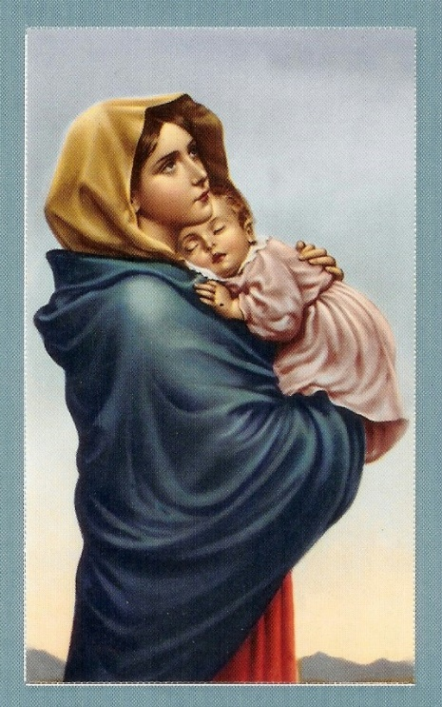
ROSARY
FOR REPECT LIFE

COME JOIN US – ALL ARE WELCOME!
Where: Memorial for the Unborn, Right Outside the Church
When: Sunday, October 2, 2022
Time: 2:30 PM
Let us pray for greater respect for all human life, from conception to natural death, and for an end to abortion, suicide, and euthanasia.

